Object oriented programming
LAB FILE

NAME – VANSH MADAAN
BATCH- B4
SAP_ID- 500123857

ROLL_NO - R2142230412

Experiment-6
1. Create a package named Balance containing a class Account with a method Display_Balance that displays the account balance. Write another program to import the Balance package and call the Display_Balance method from the Account class.
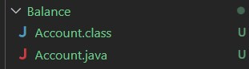
package Balance; public class Account {
public void display_balance() {
System.out.println("Account balance is 10000 Rs.");
}
public static void main(String[] args) { Account a = new Account(); a.display_balance();
}
}
//program to import the Balance package and call the Display_Balance method from the Account class import Balance.Account; public class lab6_first { public static void main(String[] args) { Account a = new Account(); a.display_balance();
}
}
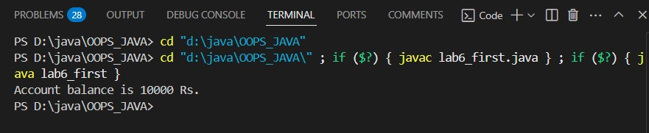
2. Create a package p containing a class A with four methods, each having different access modifiers (e.g., public, protected, default, and private). Write another class B in a different package Q with a main() method. Demonstrate how to access the methods of class A from class B, considering the access modifiers.
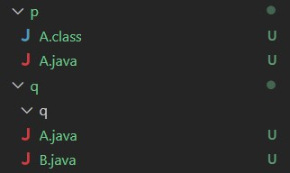
Errors:
S D:\java\OOPS_JAVA> cd "d:\java\OOPS_JAVA\p"
PS D:\java\OOPS_JAVA\p> cd "d:\java\OOPS_JAVA\p\" ; if ($?) { javac A.java } ; if ($?) { java A }
Error: Could not find or load main class A
Caused by: java.lang.NoClassDefFoundError: A (wrong name: p/A)
PS D:\java\OOPS_JAVA\p>
PS D:\java\OOPS_JAVA> cd "d:\java\OOPS_JAVA\q"
PS D:\java\OOPS_JAVA\q> cd "d:\java\OOPS_JAVA\q\" ; if ($?) { javac B.java } ; if ($?) { java B }
B.java:3: error: package p does not exist import p.A; // Import class A from package p
^B.java:6: error: cannot find symbol public class B extends A {
^symbol: class A
B.java:11: error: cannot find symbol obj2.publicMethod(); // Accessible (public)
^ symbol: method publicMethod() location: variable obj2 of type B
B.java:12: error: cannot find symbol obj2.protectedMethod(); // Accessible (protected, via inheritance)
^
symbol: method protectedMethod() location: variable obj2 of type B
4 errors
PS D:\java\OOPS_JAVA\q> package p; public class A { public void publicMethod() {
System.out.println("Public Method");
}
protected void protectedMethod() {
System.out.println("Protected Method");
}
void defaultMethod() {
System.out.println("Default Method");
}
private void privateMethod() {
System.out.println("Private Method");
}
public static void main(String[] args) { A obj = new A(); obj.publicMethod(); obj.protectedMethod(); obj.defaultMethod(); obj.privateMethod(); // Accessible here (inside the same class)
}
}
package q; import p.A; public class B extends A { public static void main(String[] args) { B obj2 = new B(); obj2.publicMethod(); // Accessible (public) obj2.protectedMethod(); // Accessible (protected, via inheritance)
// obj.defaultMethod(); //Not Accessible (default access is restricted to the same package)
// obj.privateMethod(); //Not Accessible (private methods are never
accessible outside their class)
}
}
3. Write a Java program to demonstrate the use of the final keyword with a variable and a method. Create a class MathConstants with a final variable PI (value = 3.14159) and a final method displayPI() that prints the value of PI.
Create another class Circle that extends MathConstants and includes a method calculateArea(double radius) to calculate and print the area of a circle using the formula: area = PI * radius * radius. In the main() method (in a separate class or Circle), test the calculateArea() method and observe the behavior when attempting to modify the PI variable or override the displayPI() method.
public class MathsConstants { final double PI = 3.14159; final void displayPI() {
System.out.println("Value of PI is: " + PI);
}
}
public class lab6_third { public static void main(String[] args) { Circle c = new Circle(); c.displayPI();
c.calculateArea(5);
}
}
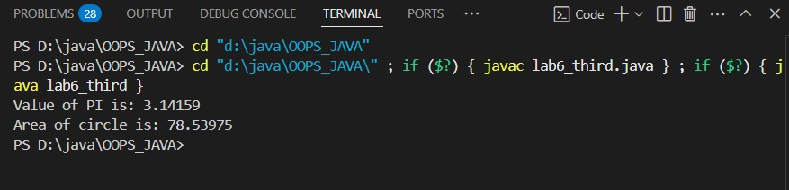
4. Write a Java program to demonstrate the use of the final keyword with a class. Create a final class Logger with a method logMessage(String message) that prints the message to the console. Attempt to create another class ExtendedLogger that extends the Logger class, and observe and explain the result. In the main() method (in a separate class), create an object of the Logger class and call the logMessage() method to print a sample message.
=>
public class lab6_fourth {
public static void main(String[] args) { Logger l = new Logger(); l.logMessage();
}
}
final class Logger { public void logMessage() {
System.out.println("Message");
}
}
/*class ExtendedLogger extends Logger {
//trying to extend a final class will result in a compile-time error
}
*/
